**ABSTRACT**

At colleges, both students and their lecturers always claim troubles caused by bad time table especially when there are any changes that requires rescheduling the usual academic teaching timetable. Due to any changes, time tables are revised and edited, and everyone using it is concerned and involved in those activities.

Usually the academic Teaching timetable is structured in such a way the many lectures can teach in same room only in different times. At this point they might be same mistake done by academic officer or head of department on how to places course, lectures, room availability all means that once that happened they will have to start from scratch hence are reschedule the academic teaching timetable.

To implement the Academic Teaching Timetable System, the academic officer will have to add all related requirement data needed for academic year in order to stored and be used in implementation of Academic Teaching Timetable. Once the Timetable has been implemented it will be visible to all co-workers. That explicitly means that each user either academic service officer, lecture, representative students will view his/her relative timetable At this point current year is the level of studies that goes with academic year.

This is a system with objective to contribute in solving some issues mentioned as it will be able to record and provide report to academic service office and head of departments about lectures /students versus departments, levels, courses, and rooms that has been used in the whole college.

In order to implement this system, a number of technologies and methodology must be studied and understood, these include implementation technologies such as programming language and methodology used to implement it.

This document will discuss each of the underlying techniques and technologies to design and implement ACADEMIC TEACHING TIMETABLE SYSTEM.

LIST OF FIGURE:

Figure 1 Architecture design of the new system 27

Figure 2 Data Flow Diagram 28

Figure 3 Use Case Diagram 30

Figure 4 Academic service officer flow chart 31

Figure 5 Head of Department flow chart 31

Figure 6 Lecture flow chart 32

Figure 7 Student flow chart 32

Figure 8 ERD Diagram 37

Figure 9 Login page 38

Figure 10 Dashboard page 39

Figure 11 Setting page 39

Figure 12 Department page 40

Figure 13 Levels page 40

Figure 14 Room and Labs 41

Figure 15 Course Views 41

Figure 16 New course 42

Figure 17 New timetable 42

Figure 18 Timetable 43

LIST OF TABLES

Table 1 User Table 33

Table 2 Setting Table 33

Table 3 Department Table 34

*Table* 4  *Department Table* 34

Table 5 Level Table 34

Table 6 Courses Table 35

Table 7 Rooms Table 35

Table 8 Timetable Table 36

# LIST OF ABBREVIATIONS

**IT**: Information technology

**PHP**: Hypertext Pre Processor

**CSS**: Cascading Style Sheet

**HTML:** Hypertext markup language

**DFD:** Data flow diagram

**ERD**: Entity relationship diagram

**SQL:** Structure query language

**ICT:** Information and Communication Technology

**IPRC:** Integrated Polytechnic Region College

**ATTS**: Academic Teaching Timetable System

LIST OF ABBREVIATIONS 4

CHAPTER ONE: INTRODUCTION 8

1.1 General Introduction 8

1.2 Background 8

1.3 Problem Statement 9

1.4 Proposed Solution 9

1.5 Objectives 10

1.5.1 General Objectives 10

1.5.2 Specific Objectives 10

1.6 Hypothesis of the study 10

1.7 Scope and Limitation of the study 11

1.7.1 Content scope 11

1.7.2 Geographical Scope 11

1.7.3 Limitation 11

1.8 Interest of the project 11

1.8.1 Personnel interest 11

1.8.2 Community Interest 11

1.9 Organization of the study 11

CHAPTER TWO: LITERATURE REVIEW 13

2.1 Introduction: 13

2.2 Existing system 13

2.3 Similar system 13

2.3.1 MyClassCampus School 13

2.3.2 QuickSchools 14

.2.3.3 Edsys 14

2.4 Current system in context of services delivery 14

2.5.1 Application 14

2.5.2 Database 15

2.5.3 Data entry 15

2.5.4 DBMS 15

2.5.5 Field 15

2.5.6 Foreign key 16

2.5.7 Normalization 16

2.7 Internet 16

2.7.3.1 Definition 17

2.7.3.2 The main goals UML 17

CHAPTER THREE: REASERCH METHODOLOGY 19

3.1 Introduction 19

3.2 Data collection Methods 19

3.3 Interview 19

3.4 Documentation 20

3.5 Software development methodology 20

3.6 Waterfall model 20

3.7 Review of existing system 20

CHAPTER 4. SYSTEM DESIGN AND IMPLEMENTATION 21

4.1 Introduction 21

4.1.1 System study 21

4.2. Data analysis and presentation 21

4.3. Description of Existing System 21

4.5. Description of the New System 22

4.5.1. Modules 22

4.5.2. System configuration and technology (Platform) 22

4.6 Tools, techniques and languages used in developing the software 22

4.6.1 PHP 23

4.6.2 MySQL 23

4.6.3 Gimp 24

4.6.4 MySQL workbench 24

4.6.5 PhpMyAdmin 24

4.6.6 Design 25

4.6.7 Develop 25

4.6.8 Administer 25

4.6.9 Visual performance dashboard 25

4.6.10 Database migration 26

4.6.11 HTML/CSS 26

4.7 Architecture design of the new system 27

4.8 Data Flow Diagram (DFD) 28

4.9 Use case diagram 29

4.10 Illustration of the new system 30

4.11 Data Dictionary 33

4.11.1 User Table 33

4.11.2 Settings Table 33

4.11.3 department Table 33

4.11.4 Levels Table 34

4.11.5 courses Table 34

4.11.6 Room Table 35

4.11.6 Timetable Table 36

4.12 Entity Relationship Diagram 37

4.13 Implementation and Coding 38

4.13.1. Introduction 38

4.13.2. Interface design 38

CHAPTER FIVE. CONCLUSION AND RECOMMENDATIONS 44

5.1 Conclusion 44

5.2 Recommendation 44

References 45

# CHAPTER ONE: INTRODUCTION

## **1.1 General Introduction**

Time table is a method of scheduling the use and distribution of both teachers and classrooms to the students. [1] Time table making is really such an overwhelming job which requires many people assistance and it’s always hard to make a suitable one compatible with everyone’s activities and availability.

At colleges, both students and their lecturers always claim troubles caused by bad time table especially when there are any changes that requires rescheduling the usual organization. Due to any changes, time tables are revised and edited, and everyone using it is concerned and involved in those activities, otherwise, some people get preferential treatment and others are left behind.

Usually the academic Teaching timetable is structured in such a way the many lectures can teach in same room only in different times. For Example, a lecture of one module can teach on room A at 8:00 to 8:50 whereas a lecture can teach in the room from 8:50 - 9:40. With that mechanism, the whole process goes by having different lecturers who have the sometime hour to same place.

To implement the Academic Teaching Timetable System, the academic officer will have to add all related requirement data needed for academic year in order to stored and be used in implementation of Academic Teaching Timetable. So the lectures and student will have to view his/her timetable that has been implemented by academic service officer. but for the lectures they will view according to their courses.

By using Academic Teaching Timetable system, it will provide a report to academic, and heads of departments about lectures/students versus departments, levels, courses and rooms in the whole college.

That explicitly means that each user either academic, lecture, representative students will view his/her relative timetable at this point current year is the level of studies that goes with academic year.

**1.2 Background**

In IPRC TUMBA, like any other academic institution, the situation in which the students attend their classes involves the same above-mentioned problem of class timetable arrangement, as our case study, we came to find that most students and lecturers get difficulties finding a suitable timetable because there is no room for everyone to give his/her own ideas. Therefore, we came to think of help removing those excuses made by lecturers and students and also ease the amount of job done by academic services office and head of departments as well.

**1.3 Problem Statement**

After considering time crises especially in our college (IPRC TUMBA) yet there are often time wastages, human error caused by same mistaken so I came to think of a proposed solution which is “Academic Teaching Timetable system”.

After I realizing some issues such as time wastage of gathering academic service officer and head of department, they take time for checking if everything is available and material that will be used in academic year, I came to find that college staff and students face the following challenges:

Lack of consistency in student activities: when class schedules are changing regularly, it affects the usual activities of students because time management get hard, Time management is also another issue caused by these changes, this affects both sides, the lecturer timing for finishing module, and student private activities.

**1.4 Proposed Solution**

Base on the problem that has been facing the academic teaching timetable, with this system those claimed that has been made by lectures and student will be solved by providing and implement timetable that is compatible with. The timetable will be visible to all user accordingly, for lecture timing will be appropriately defined and well shown.

It is in this regard that we came up with a solution to the problem through the system entitled, “Academic Teaching Timetable system”. With this system higher learning institutions and universities like IPRC TUMBA will be able to minimize that overwhelming job of preparing timetables and the risks of finding out that prepared timetables are not suitable to neither students nor lecturers. It will be a web-based application which will be used by the timetable and examination officers, where the officers will only be required to enter the lessons, lecturers, and available classrooms and the rest of the job will be expected to be done by the system itself, and in case of any changes, the system will be such dynamic to adjust to immediate changes and only the concerned individuals will be noticed without getting others affected by those changes.

**1.5 Objectives**

**1.5.1 General Objectives**

General objective of our project is to design and implement Academic Teaching Timetable system that will help in generating academic timetable.

**1.5.2 Specific Objectives**

Our main purpose is to provide a convenient way to overcome the problems of time wastage on all sides of the academic related individuals as follows:

* To allow academic service officer be able to add new academic year.
* To allow academic service officer to add departments, levels, courses, rooms for that academic year that has been added.
* To allow academic service to implement and its will be generated automatically.
* To allow head of departments to add new lectures and student representatives and assign course to those lectures.
* To allow academic service officer smoothly manage their academic schedule
* To allow lectures view courses and timetable that has been implemented.
* To keep data for every lecture’s students belongs in.
* To allow the students know room where the course will delivery and lecturer’s work load and also the timetable that has been implemented.
* To allow academic service officer to update timetable whenever the new lecture register

**1.6 Hypothesis of the study**

The system comes to facilitate at the IPRC TUMBA, with that implemented academic teaching timetable, those issue that was faced before developing system will be solved and available.

**1.7 Scope and Limitation of the study**

**1.7.1 Content scope**

This system is all about to implement academic teaching timetable automatically be generated and store all related reports that has been used in different academic years.

### 1.7.2 Geographical Scope

This research solution will be used in IPRC TUMBA, Rulindo district, RWANDA.

**1.7.3 Limitation**

This system can be used in academic teaching to implement timetable only and also it will store all related reports that has been used to implement timetable for academic year.

**1.8 Interest of the project**

**1.8.1 Personnel interest**

Normally there are a lot of interests including to be a warded an advanced diploma, applying our knowledge in order to improve in information communication technology and also if the system becomes successful I will gain some amount of money from it delivered by those one who want to use it.

**1.8.2 Community Interest**

The system is going to help community (student’s representatives, lectures) especially IPRC TUMBA be aware of which course has to be taken at what time.

**1.9 Organization of the study**

**Chapter One: General introduction:** it describes the introduction about the system, background of the system, objectives (general and specific), and the scope project.

**Chapter Two: The Literature Review:** The chapter tells in details what others have done about the system and indicates some of the existing systems. T also talks about the concepts related to my study.

**Chapter Three: Research methodology,** this chapter explains methods which are used to collect data during research about academic teaching timetable system.

**Chapter Four: System Design and Implementation,** this chapter is the phase that helps to understand different techniques, implementation and design of the system.

**Chapter Five: Conclusion and Recommendation,** this chapter closes document with conclusion made according to the observation and recommends to the different parties that could benefit from the system.

**CHAPTER TWO: LITERATURE REVIEW**

**2.1 Introduction:**

The idea of development of Academic Teaching Timetable system initially came as a solution that can be applied in education college. It will definitely improve daily activities of the lectures, students, in the college.

**2.2 Existing system**

The Academic Teaching Timetable is done in such a way that the academic staff know how many room, labs, levels available and courses that will have taught in the semester, then the head of department assigns courses to lectures, and both of them they sat together and arrange the timetable, they have to know whether no lecture can have same course on the same day at the same hours in the room. This means each department deals with its reference according the lectures they have. that is a very tiring job for both academic staff and head of departments.

Some troubles come when a new lectures or extend hours has to be added in the time table because there might be mistake of assign two or more lectures or class to same room at the same hours. There is no validation to insecure that no mistake could be done.

The other problem found in the existing system is that academic staff cannot know the avoid in the timetable (the unassigned hour in timetable). Means no record stored that shows the unused hours, room, labs. That on the other hand causes problem because the student, by having unplanned free time, changeable timetable might be victim of poor system.

**2.3 Similar system**

The different system that seems to be similar to mine. I have made research but in the tail there are bugs that go with them. Let’s through them and check differences,

**2.3.1 MyClassCampus School**

ERP helps institute to create quickly multiple timetables which save an adequate amount of administrative time and effort. Through this School Administration Software, it will be easy to manage Proxy period of teachers, which save the time and efforts of administrative staff. Creating timetable, assigning proxy period, and managing faculty timetable is very easy with our Institute Management System. The gap is that the course that they required that does not need course credit in order to know hours that course will taught, most timeslot are changeable that led to inadequate for our college. The methodology mostly the used is to request all necessary data for implement that timetable. [2]

**2.3.2 QuickSchools**

Supports a wide range of scheduling needs, from straightforward Homeroom scheduling in elementary to middle schools, to a mix of complex electives, period-based scheduling more commonly found in middle to high schools, this one is used in secondary and might be used in college. The gaps that has is that seems to use as scheduling no to implement timetable and also it used in middle schools and lower schools. The methodology are is only create schedule for each class. [3]

**.2.3.3 Edsys**

Unanimous requirement for planning class timings in school. The system can be deployed to schedule a new class, cancel an existing class, and making other changes to a timetable. Also this does not implement timetable automatically depends on course available for the student. It require to map course to its time that will be taken. [4]

**2.4 Current system in context of services delivery**

The New system is brilliant, the jobs of academic staff and head of departments are being made so easy. The academic staff and heads of departments cannot make duplicate in timetable, that work like this the system validate each individual lectures, courses with his lecture; where by many lectures can have same courses and a course to be taught by many lecturers. The next thing is that combination is mixed with hours and room, where by the same lectures can be assigned that combination but with unique hour.

**2.5 Terms used in the systems**

**2.5.1 Application**

Software that process data for the user, Except for “system software.” This provides the infrastructure in the computer (operation system utilities and related components).

In the entertainment world, it refers to games (see gaming). In the business world, it refers to the data entry, update, query and report programs that make up the company’s bread and butter information systems order entry, billing, inventory, human resources, payroll, manufacturing….

The term may also refer to generic application, often called a “productivity program,” such as a Web browser, spreadsheet, word processor, database or e-mail program. [5]

**2.5.2 Database**

A collection of related information used in a structured format. Database is often used into interchangeably with the term table (Lotus Approach, for instance, uses the term database instead of table). Technically, they are different: A table is a single store of related information; a database can consist of one or more tables information that are related in some way. For instance, you could track all the information about the students in a school in a student’s table.

If you then created separate tables containing details about teachers, classes and classrooms, you could combine all four tables into a timetabling database. Such as multi-table database in called a relational database. [6]

**2.5.3 Data entry**

The process of getting information into a database, usually done by people typing it in by way of data-entry forms designed to simplify the process

**2.5.4 DBMS**

Database management system, a program which lets you manages information in databases.

Lotus Approach, Microsoft Access and FileMaker Pro, MySQL for example, are all DBMSs, although the term is often shortened to “database”. So, the same term is used to apply to the program you use to organize your data and the actual data structure you create with that program. [6]

**2.5.5 Field**

Fields describe a single aspect of each member of a table. A crime credit, for instance, might contain a credit id field, crime name a, first name field, and so on.

All records have exactly the structure, so they contain the same fields. The values in each field vary from record to record, of course. In some database systems, you’ll find fields referred to as attributes.

**Flat file**: A database that consists of a single table. Lightweight database program such as the database component in Microsoft Works are sometimes called ’flat-file managers’ (or list managers) because they can only handle single-table databases.

More powerful programs such as FileMaker Pro, Access, Approach and Paradox, can handle multi-Table databases, and are called relational database managers, or RDBMSs

**2.5.6 Foreign key**

A key used in one table to represent the value of a primary key in a related table. While primary keys must contain unique values, foreign keys may have duplicates. For instance, if we use suspect person ID as the primary key in a suspect table (each suspect has a unique ID), we could use suspect ID as a foreign key in a crime table: as each suspect person can do more than one crime, the suspect ID in the crime table (often shortened to crime, suspected) will hold duplicated values.

**2.5.7 Normalization**

The process of structuring data to minimize duplication and inconsistencies. The process usually involves breaking down a single table into two or more tables and defining relationships between those tables. Normalization is usually done in stages, with each stage applying more rigorous rules to the types of information which can stored in a table. While full adherence to normalization principles increase the efficiency of a particular database, the process can become so esoteric that you need a professional to create and understand the table design. Most people, when creating a database, don’t need to go beyond the third level of normalization, called third normal form. And there’s no need to know the terminology, simply applying the principles is sufficient.

**2.7 Internet**

Internet refers to a network of networks that consists of millions of private, public, academic, business and government networks of local to global scope, that are linked by a board array of electronic and optical networking technologies. Internet communication takes places through the use of email. A multi-tiered system of local, regional and national ISPs has evolved to provide access to the internet, transport data and, more recently to provide value-added internet enhancing internet communication. [1]

**2.7.1 Website**

Websiteis a set of related web pages served from a single web domain. A website is hosted on at least one web server, accessible via a network such as the internet or a private local area network though an internet address known as a uniform resource locator. All publicly accessible websites collectively constitute the World Wide Web.

**2.7.3 What is UML?**

**2.7.3.1 Definition**

The Unified Modeling Language (UML) is a standard language for specifying, visualizing, constructing and documenting the artifacts of software systems, as well as for business modeling and other non-software systems.

The UML represents a collection of best engineering practices that have proven successful in the modeling of large and complex systems. The UML is a very important part of developing objects oriented software and the software development process.

The UML uses mostly graphical notations to express the design of software projects. Using the UML helps project teams communicate, explore potential designs and validate the architectural design of the software.

**2.7.3.2 The main goals UML**

The primary goals in the design of the UML we are:

* Provide users with a ready to use, expressive visual modeling language so they can develop and exchange meaningful models.
* Provides extensibility and specialization mechanisms to extend the core concepts.
* Be independent of particular programming languages and development processes.
* Provide a formal basis for understanding the modeling language.
* Encourage the growth of the Object Oriented tools market
* Support higher-level development concepts such as collaborations, frameworks, patterns and components.
* Integrate best practices. [13]

**CHAPTER THREE: REASERCH METHODOLOGY**

**3.1 Introduction**

This chapter deals with how to find out the result of a given problem on a specific matter or problem that is also referred as research problem Methodology, researcher uses different criteria of solving /researching the given research problem. Different resources use different type of methods for solving the problem. If I think about the word ‘methodology’, it is the way of searching or solving the research problem. It is no easy to imagine a system of information without having complete information of what happens within the location in its activities of everyday. To reach this, it was necessary to use different methods to collect the information coming from users.

**3.2 Data collection Methods**

Data collection is a term used to describe a process of gathering (or obtaining) specific information about a phenomenon or an activity. Once collected, data can be stored in databases, analyzed and used for purposes of monitoring or evaluation. The quality of data collected has a direct impact, upon the quality of analysis that can be performed using the data, which ultimately impacts upon the quality of decision that can be made. In my research I used four techniques of data collection like the documentation, the interview, observation and question. These techniques give a good output when they are used together.

**3.3 Interview**

The methodology used to gather data was to have Academic staff in charge of timetable of courses and ask how they prepare academic timetable and how they know to structure the lectures and course to be taught. And also student I ask them how get timetable, how do they claim if something is wrong.

The questions that has been asked during interviews was: what recorded needed to implement timetable, is there any obstacle in implementation, is there any claims made by lectures, students. On the student side they were asked about what could be changed during the implementation of academic timetable.

**3.4 Documentation**

Some of the documentation was extracted from IPRC TUMBA website iprctumba.rp.ac.rw, where they state the student’s life, administration and academics. Them most of the rest information was done in form of interview when the developers visited the college.

Other was done books that show how to implement timetable with what method could be used during to implement.

**3.5 Software development methodology**

In a way to achieve this system entitled, I choose software development process that is structured imposed on the development of software product. As software development life cycle (SDLC) model I have chosen one of the popular methodologies known as waterfall model.

**3.6 Waterfall model**

The waterfall model is a sequential design process, often used in software development processes, in which progress in seen as flowing steadily down through the phases of concept, initiation, Analysis, Design, Testing, Production/ Implementation, and Maintenance. [2]

**3.7 Review of existing system**

Document review was used to understand the current system and get relevant literature of the academic Teaching timetable system techniques that are being used. A number of documents were reviewed ranging from room, lecture, levels management and other related college issues.

In my research that have conducted, I have seen that existing system that were used to implement timetable was to have all head of departments and academic service officer in charge of timetables, then they review all requirement that will be needed to implements that timetable for that academic year, hence after review they will have plan it.

**CHAPTER 4. SYSTEM DESIGN AND IMPLEMENTATION**

**4.1 Introduction**

The system design is used to describe the topic towards the main goal. The purpose of design this phase is to plan a solution of the problem specified in the requirement specification document and overcome the problem that goes through timetable system. The main goal of the project is to develop a web based system that will help academic to implement Academic Teaching timetable system in IPC TUMBA.

This phase introduces techniques of design of the interfaces, menus, and databases based on the requirement specification worked out during the analysis phase such as functioning, relationship, dataflow diagram.

This is the first way for loading from the problem domain to the solution domain. In the other side, starting with that is needed; design takes us towards the necessary needs. The design of the system is the most critical factor affecting the quality of the software. It gives impact on the delayed phases as well as testing and maintenance of the software.

**4.1.1 System study**

To develop a best fit system to the society that responds to Academic Teaching Timetable, there are main stages of developing the system. They are analysis, design and implementation and testing. The analysis that I have used to know how implement it without causing any trouble in arrangement, gathering data by making research. The design was how will I implement its design and knowing materials i will be using. Implementation to check if working principal I have, has been made during to implement academic teaching timetable system, and Test all necessary implemented system. Within these sections, different tactics will be adopted so that we can design a system that can maintain high usability and accessibility.

**4.2. Data analysis and presentation**

According to the research I made, the data collected shows that the old system was lacking most of its functionalities because; they are still using the analog way. The student was still getting timetable manual on paper and also lectures will have to complain to the head of department that they don’t have timetable.

**4.3. Description of Existing System**

The existing system that are used to implement Academic Teaching Timetable, were the academic staff and head of department sat together and check all requirement needed to implement academic teaching timetable such as available room, lab, the course that will learned in semester, course credit, the available lecture then each head of department assign course to those lecture according they qualifications each has. Then they publish Academic Teaching on board and send them to lectures, on social media.

**4.5. Description of the New System**

The new system that I have used to implement Academic Teaching Timetable, doesn’t need to bring academic staff and head of department together since the measure of covid 19 has been provided.

The new system will be used when academic staff has provided all such as room, courses, labs, levels, departments. For the head of department will register only lectures and assign those courses that has been created depends on lecture specialists, for the lecture will have to register student representative and this will be easy to get timetable and descript it to the whole students.

**4.5.1. Modules**

They are many different modules that has been implemented in this system, description of different modules that made the Academic Teaching Timetable system are module for academic that will deal with all primary functionality needed to implement timetable, and head of department that deals with lectures and class representatives, other module that will implement the academic teaching timetable system for each academic year.

**4.5.2. System configuration and technology (Platform)**

The system will be need tools to be configured. The xampp, MySQL server that will hold database. The technology of this system build-in is laravel framework version 8 that is latest, the preseason I choose this type of technology of php are, its offers built-in API support, the queries in laravel return json type. [14]

**4.6 Tools, techniques and languages used in developing the software**

**4.6.1 PHP**

PHP is a server-side scripting language designed for web development but also used as a general purpose programming languages. originally created by Rasmus Lerdorfin 1994. The PHP reference implementation is now produced by the PHP Group.

PHP originally stood for personal home page, but it now stands for the recursive backronym PHP: Hypertext Preprocessor.

PHP code may be embedded into HTL code, or it can be used in combination with various web template systems, Web content management system and Web frameworks. PHP code is usually processed by a PHP interpreter implemented as a module in the web server or as a Common Gateway Interface (CGI) executable.

The web server combines the results of the interpreted and executed PHP code, which may be any type of data including images, with the generated web page. PHP code may also be executed with a command-line interface(CLI) and can be used to implement standalone graphical applications. [7]

#### 4.6.1.1 Applications of PHP

As mentioned before, PHP is one of the most widely used language over the web. I'm going to list few of them here:

* PHP performs system functions, i.e. from files on a system it can create, open, read, write, and close them.
* PHP can handle forms, i.e. gather data from files, save data to a file, through email you can send data, return data to the user.
* You add, delete and modify elements within your database through PHP.
* Access cookies variables and set cookies.
* Using PHP, you can restrict users to access some pages of your website.
* It can encrypt data.

**4.6.2 MySQL**

Is an open source RDBMS that relies on SQL for processing the data in the database? MySQL provides APIs for the languages C, C++, Java, Perl, PHP and Python. In addition, OLE-DB and ODBC providers exit for MySQL data connection in the Microsoft environment. A MySQL.NET Native Provider is also available, which allows native MySQL to.NET access without the need for OLE_DB (Object linking and Embedding Database).

MySQL is most commonly used for web Application and for embedded application and has become a popular alternative to proprietary database systems because of its speed and reliability. MySQL can run on UNI, Windows and Mac OS. [6]

**4.6.3 Gimp**

GIMP is an acronym for GNU Image Manipulation Program. It is a freely distributed program for such tasks as photo retouching image composition and image authoring.

It has many capabilities it can be used as a simple paint program, an expert quality photo retouching program, an online batch processing system, a mass production image renderer, an image format converter, etc. [8]

**4.6.4 MySQL workbench**

MySQL Workbench is a unified visual tool for database architects, developers and DBAs. MySQL Workbench provides data modeling. SQL development and comprehensive administration tools for server configuration, user administration, backup and much more MySQL Workbench is available on Windows, Linux and Mac OS X. [9]

**4.6.5 PhpMyAdmin**

PhpMyAdmin is an open source tool written in PHP intended to handle the administration of MySQL with the use of a browser. It can perform various tasks such as creating, modifying or deleting databases, tables, fields or rows, executing SQL statements or managing users and permissions.

Features provided by the program include:

* + - * Web interface
      * MySQL database management
      * Import data from CSV and SQL.
      * Export data to various formats: SQL, XML, PDF, Spreadsheet, Word, Excel and etc.
      * Administering multiple servers
      * Creating PDF graphics of the database layout
      * Searching globally in a database or a subset of it
      * Transforming stored data into any format using a set of predefined functions.
      * Active query monitor (Processes). [10]

**4.6.6 Design**

MySQL Workbench enables a DBA, developer, or data architect to visually design, model, generate and manage databases.it include everything a data modeler needs for creating complex ER models, forward and reverse engineering and also delivers key features for performing difficult change management and documentation tasks that normally require much time and effort.

**4.6.7 Develop**

MySQL Workbench delivers visual tools for creating, executing and optimizing SQL queries. The SQL Editor provides color syntax highlighting, auto-complete, reuse of SQL snippets and execution history of SQL. The Database Connections panel enables developers to easily manage standard database connections, including MySQL Fabric. The Object Browser provides instant access to database schema and objects. However, this is very crucial in designing databases.

**4.6.8 Administer**

MySQL. Workbench provides a visual console to easily administer MySQL environments and gain better visibility into databases.

Developers and DBAs can use the visual tool for configuring servers, administering users, performing backup and recovery, inspecting audit data and viewing database health. Thus, administration is the most important feature in whatever application.

**4.6.9 Visual performance dashboard**

MySQL Workbench provides a suite of tools to improve the performance of MySQL applications. DBAs can quickly view key performance indicators using the performance dashboard. Performance reports provide easy identification and access to IO hotspots, high cost SQL statements and more.

Plus, with I click developers can see where to optimize their query with the improved and easy to use visual explain plan. Therefor visual-based design is so reliable.

**4.6.10 Database migration**

MySQL Workbench now provides a complete, easy to use solution for migrating Microsoft SQL Server, Microsoft Access, Sybase ASE, PostgreSQL and other RDBMS tables, objects and data to MySQL. Developers and DBAs can quickly and easily convert existing applications to run on MySQL both on Windows and other platforms. Migration also supports migrating from earlier versions of MySQL to the latest releases. [11]

**4.6.11 HTML/CSS**

Hypertext Markup Language (HTML) is the standard [markup language](https://en.wikipedia.org/wiki/Markup_language" \t "Markup language) for documents designed to be displayed in a [web browser](https://en.wikipedia.org/wiki/Web_browser" \t "Web browser). It can be assisted by technologies such as [Cascading Style Sheets](https://en.wikipedia.org/wiki/Cascading_Style_Sheets" \t "Cascading Style Sheets) (CSS) and [scripting languages](https://en.wikipedia.org/wiki/Scripting_language" \t "Scripting language) such as [JavaScript](https://en.wikipedia.org/wiki/JavaScript" \t "JavaScript).

[Web browsers](https://en.wikipedia.org/wiki/Web_browser" \t "Web browser) receive HTML documents from a [web server](https://en.wikipedia.org/wiki/Web_server" \t "Web server) or from local storage and [render](https://en.wikipedia.org/wiki/Browser_engine" \t "Browser engine) the documents into multimedia web pages. HTML describes the structure of a web page [semantically](https://en.wikipedia.org/wiki/Semantic_Web" \t "Semantic Web) and originally included cues for the appearance of the document.

[HTML elements](https://en.wikipedia.org/wiki/HTML_element" \t "HTML element) are the building blocks of HTML pages. With HTML constructs, [images](element) and other objects such as [interactive forms](https://en.wikipedia.org/wiki/Fieldset" \t "Fieldset) may be embedded into the rendered page. HTML provides a means to create [structured documents](https://en.wikipedia.org/wiki/Structured_document" \t "Structured document) by denoting structural [semantics](https://en.wikipedia.org/wiki/Semantics" \t "Semantics) for text such as headings, paragraphs, lists, [links](https://en.wikipedia.org/wiki/Hyperlink" \t "Hyperlink), quotes and other items. HTML elements are delineated by *tags*, written using [angle brackets](Bracket). Tags such as <img /> and <input /> directly introduce content into the page. Other tags such as <p> surround and provide information about document text and may include other tags as sub-elements. Browsers do not display the HTML tags, but use them to interpret the content of the page.

Alongside [HTML](https://en.wikipedia.org/wiki/HTML" \t "HTML) and [CSS](https://en.wikipedia.org/wiki/CSS" \t "CSS), JavaScript is one of the core technologies of the [World Wide Web](https://en.wikipedia.org/wiki/World_Wide_Web" \t "World Wide Web). JavaScript enables interactive [web pages](https://en.wikipedia.org/wiki/Web_page" \t "Web page) and is an essential part of [web applications](https://en.wikipedia.org/wiki/Web_application" \t "Web application). The vast majority of [websites](https://en.wikipedia.org/wiki/Website" \t "Website) use it, and major [web browsers](https://en.wikipedia.org/wiki/Web_browser" \t "Web browser) have a dedicated [JavaScript engine](https://en.wikipedia.org/wiki/JavaScript_engine" \t "JavaScript engine) to execute it. [12]

**4.7 Architecture design of the new system**

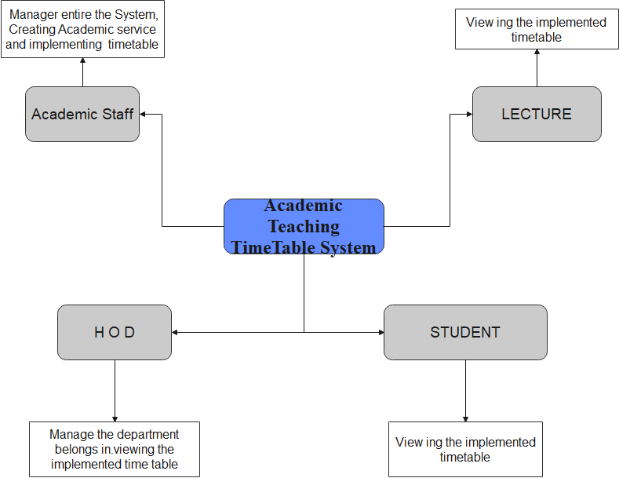

Figure 1 Architecture design of the new system

**4.8 Data Flow Diagram (DFD)**

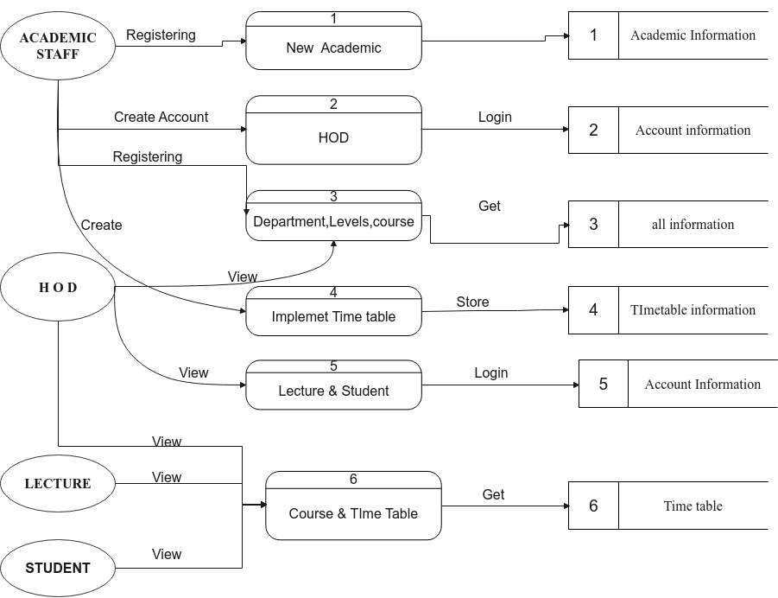

Figure 2 Data Flow Diagram

**4.9 Use case diagram**

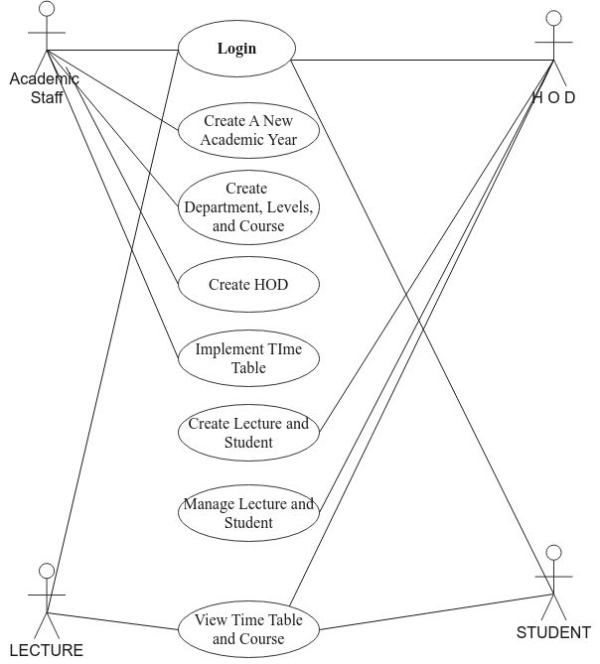

Figure 3 Use Case Diagram

This use case will explain how the different user will accomplish different tasks. Academic service offer will login into the system, then create academic year after he will have to create department, levels, rooms or labs and add courses for that academic that has been created. Also he will be able to register new head of department because often the change depends on the academic year. After academic service officer will implement the timetable by giving timetable name, department, level and semester, then it will be generated. Head of departments (HOD) will be able register new register, student representative also he will manager lectures by assign them course and view timetable for his departments. Lecture will view only timetable and courses and student will also view courses and timetable for his/her level and departments.

**4.10 Illustration of the new system**

**4.10.1 Academic service officer flow chart**

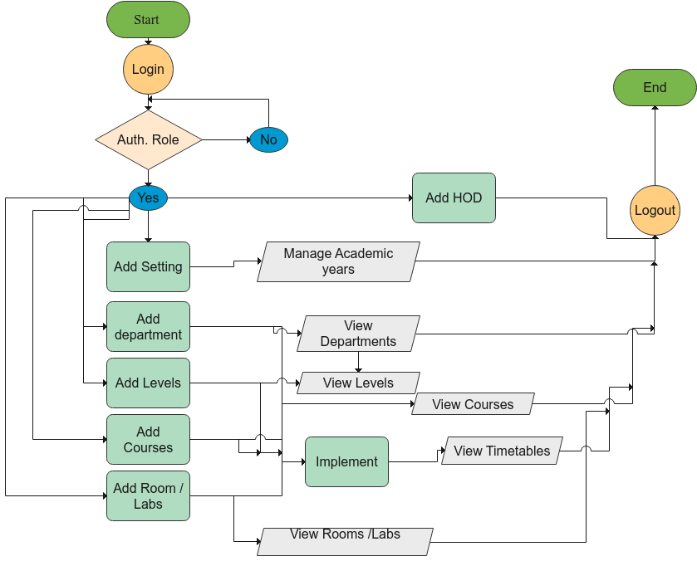

Figure 4 Academic service officer flow chart

**4.10.2 Head of department flow chart**

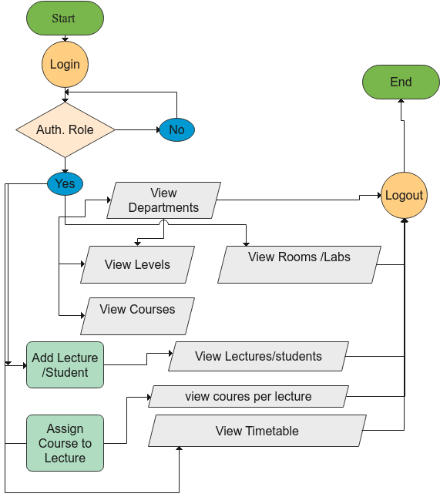

Figure 5 Head of Department flow chart

**4.10.3 Lecture flow chart**

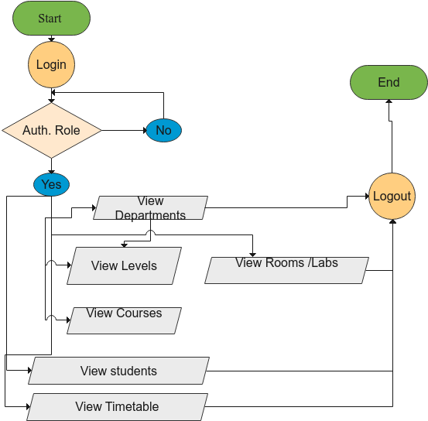

Figure 6 Lecture flow chart

**4.10.4 Student flow chart**

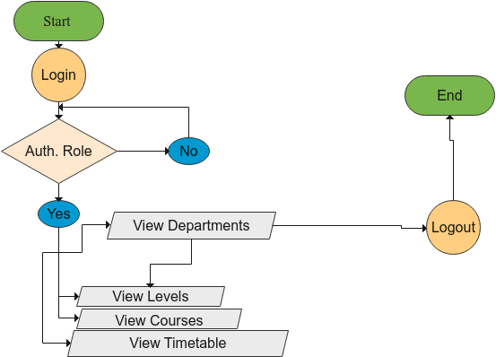

Figure 7 Student flow chart

**4.11 Data Dictionary**

### 4.11.1 User Table

|  |  |  |  |  |
| --- | --- | --- | --- | --- |
| Table Name | Column | Type | Constraints | Description |
| Users | Id | bigint(20) | Primary Key | Id of user |
| Names | varchar (255) | Not null | Username of user |
| Email | varchar (255) | Unique | Uniquely email of user |
| Role | Varchar(255) | Not null | Each user has role |
|  | Password | Varchar(255) | Not null | Password of user |

Table 1 User Table

**4.11.2 Settings Table**

|  |  |  |  |  |
| --- | --- | --- | --- | --- |
| Table Name | Column | Type | Constraints | Description |
| Settings | Id | Bigint (20) | Primary Key | Id of academic year |
| system_name | Varchar (255) | Not null | Names of system |
| status | Tinyint(1) | Not null | This check if academic is current |
| Term_begin | Varchar (14) | Not null | Date of term begin |
| Term_end | varchar (14) | Not null | Date of term end |

Table 2 Setting Table

### 4.11.3 department Table

|  |  |  |  |  |
| --- | --- | --- | --- | --- |
| Table Name | Column | Type | Constraints | Description |
| Departments | Id | Bigint (20) | Primary Key | Id of an department |
| abbr | varchar (3) | Not null | Abbreviation of department |
| description | varchar (255) | Not null | In full words department is for what. |
| setting_id | bigint20) | Foreign key | Foreign key reference to settings table |

Table 3 Department Table

*Table 4* *Department Table*

### 4.11.4 Levels Table

|  |  |  |  |  |
| --- | --- | --- | --- | --- |
| Table Name | Column | Type | Constraints | Description |
| Levels | Id | Bigint (11) | Primary Key | Id of a level |
| level_name | Varchar(255) | Not null | Name of level |
| department_id | bigint(20) | Foreign key | Foreign key on department |
| setting_id | bigint(20) | Foreign key | Foreign key on setting |

Table 5 Level Table

### 4.11.5 courses Table

|  |  |  |  |  |
| --- | --- | --- | --- | --- |
| Table Name | Column | Type | Constraints | Description |
| courses | Id | bigint (20) | Primary Key | Id of course |
| course_code | varchar (20) | Not null | code that identifies that course |
| course_name | varchar (25) | Not null | Full name of course |
| course_credit | Int(10) | Not null | A credit of course which shows hours per day |
| department_id | Bigint(20) | Foreign key | That course belong on which department |
|  | level_id | Bigint(20) | Foreign key | Each course belongs on level |
| setting_id | Bigint(20) | Foreign key | Each course has academic |

Table 6 Courses Table

### 4.11.6 Room Table

|  |  |  |  |  |
| --- | --- | --- | --- | --- |
| Table Name | Column | Type | Constraints | Description |
| Room | id | Bigint (20) | Primary Key | Id of room |
| lab_class | varchar (30) | Not null | To choose if it is lab or class |
| room | varchar (30) | Not null | Room name |
| description | varchar (20) | Not null | What we do in that room |
| status | tinyint (1) | Not null | To check if they Is available lab or class |
| department_id | Bigint(20) | Forign key | Foreign key for department |

Table 7 Rooms Table

### 4.11.6 Timetable Table

|  |  |  |  |  |
| --- | --- | --- | --- | --- |
| Table Name | Column | Type | Constraints | Description |
| Timetables | Id | Bigint (20) | Primary Key | Id of timetable |
| Timetable_name | Varchar (255) | Not null | Names of timetable |
| Department_id | bigint(20) | Foreign Key | Foreign key for department |
| Level_id | Bigint(20) | Foreign Key | Foreign key for levels |
| Semester_id | Bigint(20) | Foreign key | Semester id |
|  | Setting_id | Bigin(20) | Foreign key | Settings id for academic year |
| Schedule | Text | No null | Store arrangement of timetable |

Table 8 Timetable Table

**4.12 Entity Relationship Diagram**

An Entity-Relation diagram(ERD) typically serves as the main deliverable of a conceptual data model. While newer approaches to E-R modeling have developed, the E-R approach is still admired by some professionals as ‘the premier model for conceptual database design”. An ERD is a logical representation of an organization’s data.

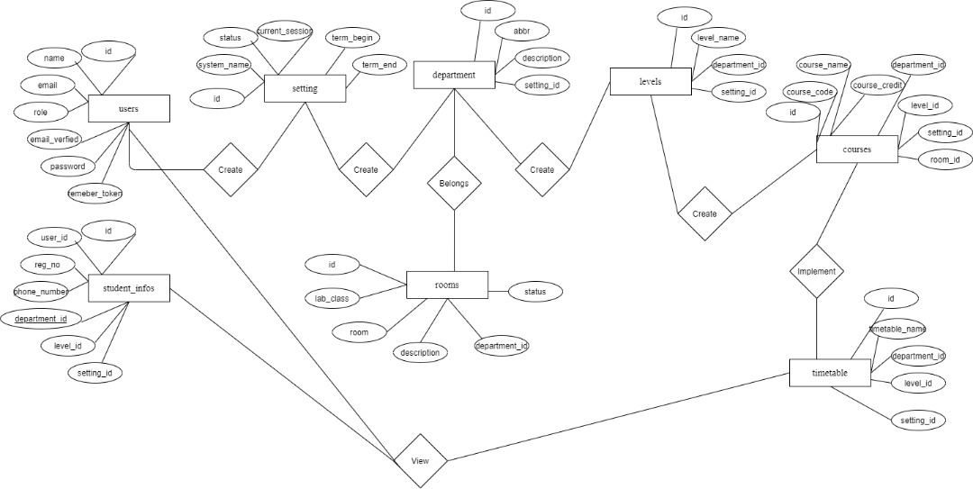

Figure 8 ERD Diagram

**4.13 Implementation and Coding**

**4.13.1. Introduction**

This chapter show how the system was implemented tools has been used, in simple words how the system looks like. The academic Teaching Timetable System in design and how the system is implemented with screenshot that I have taken during the implementation.

**4.13.2. Interface design**

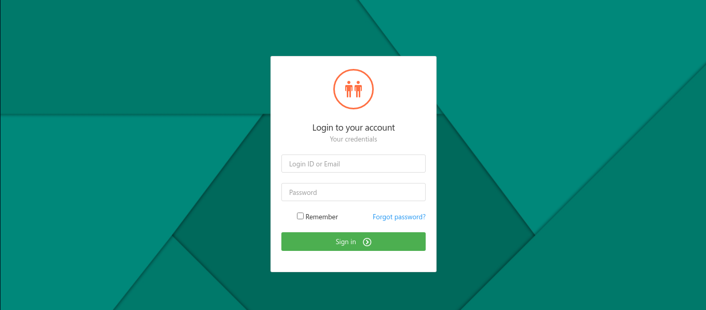

Figure 9 Login page

This login page will ask user to enter email and password then check his role after checking role redirect to corresponding home page.

**Dashboard of Academic**

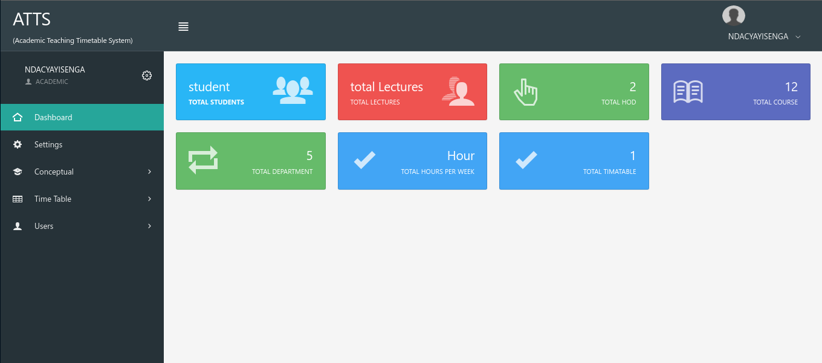

Figure 10 Dashboard page

This show all record that has been stored in the database, but its show them as acountable only no link provided.

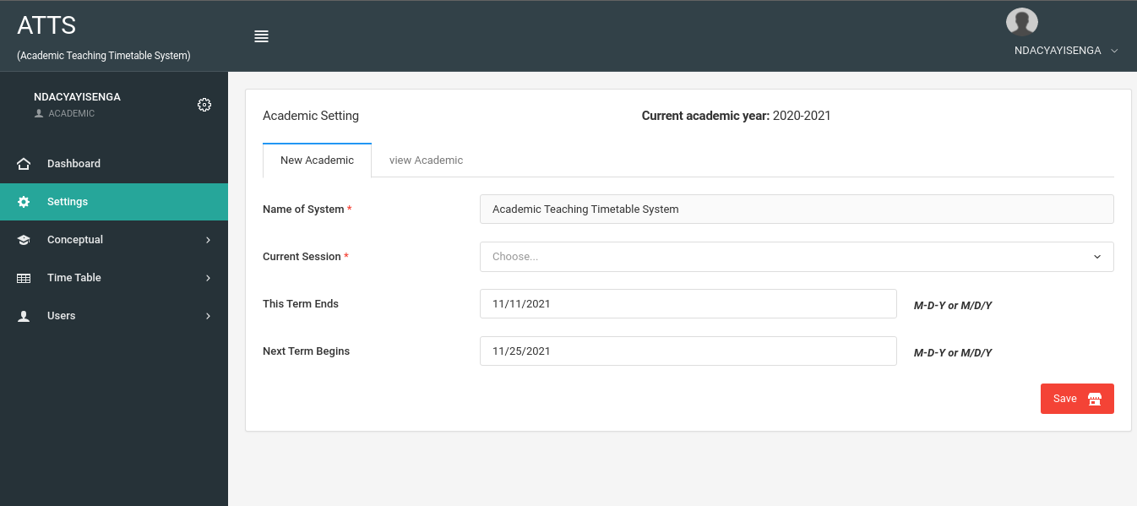

Figure 11 Setting page

This page academic service officer will manager academic year depends which year has been reached.

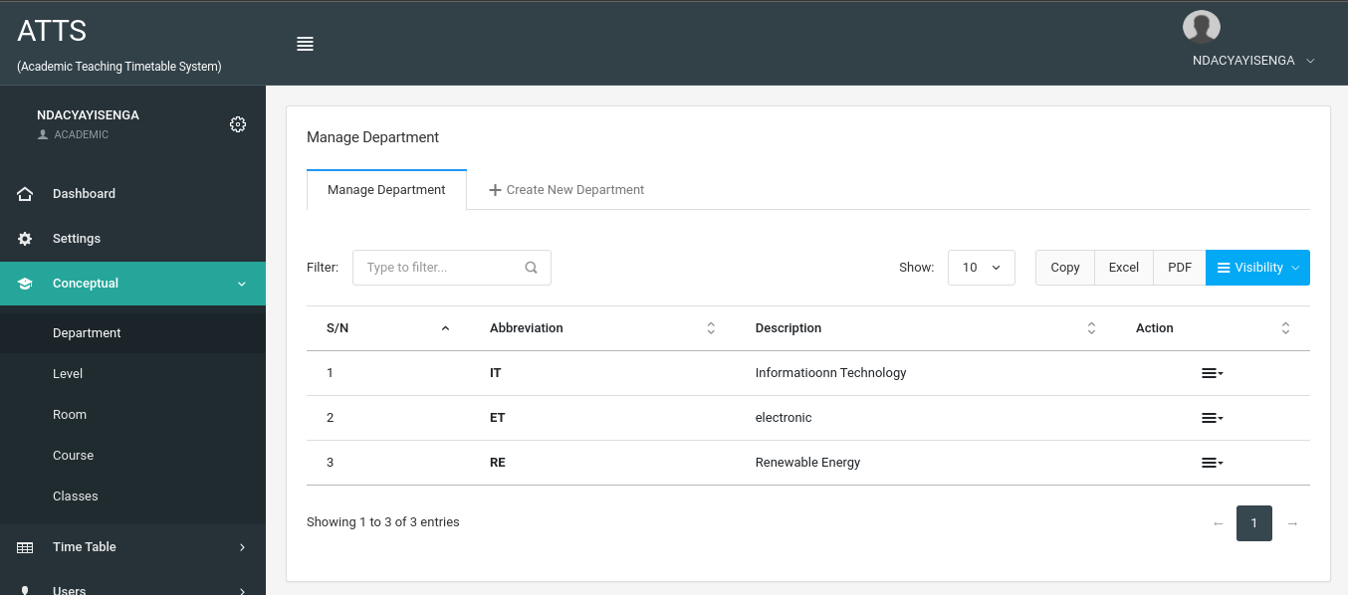

Figure 12 Department page

This page will be able to add new department within academic year and view those departments.

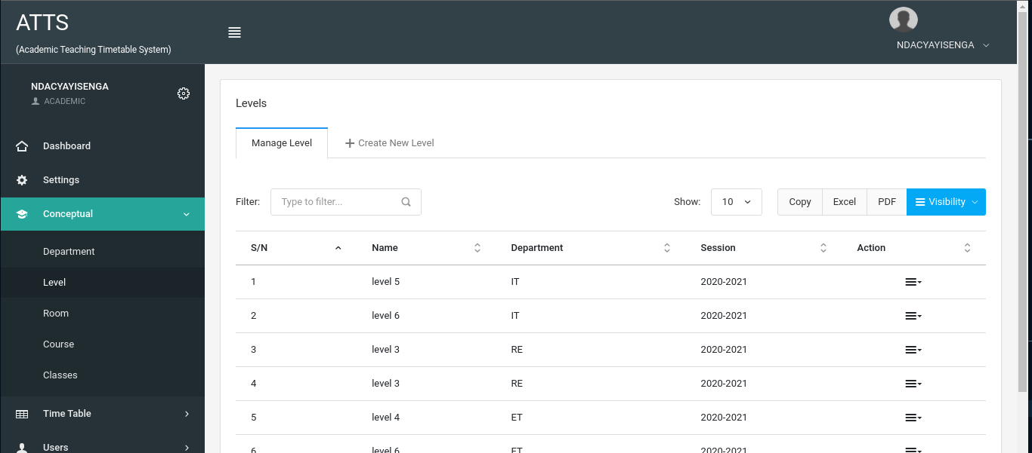

Figure 13 Levels page

This page will show levels registered in academic year also academic service officer will be able register new level depend on academic year.

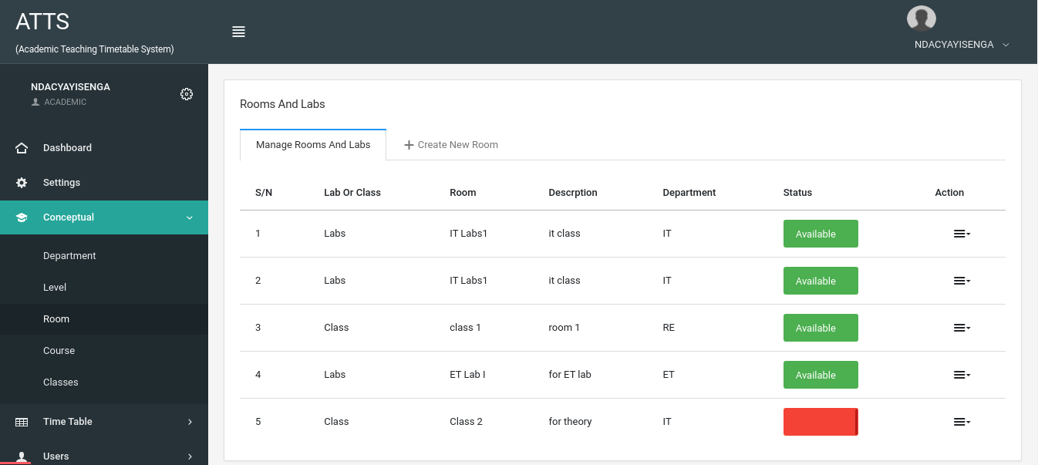

Figure 14 Room and Labs

This page will show available room and labs for each departments and also academic service officer will be able to register new new or lab.

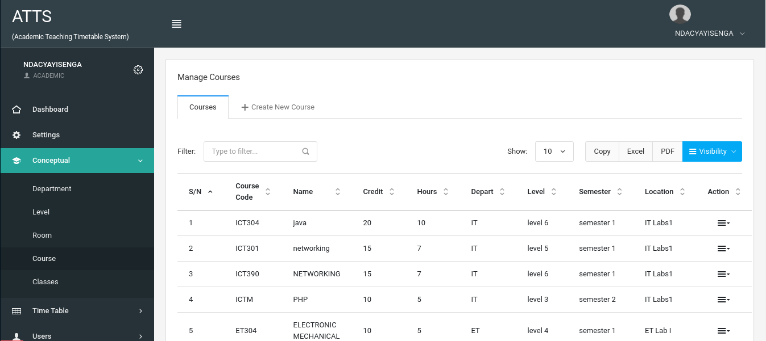

Figure 15 Course Views

This show shows in academic year

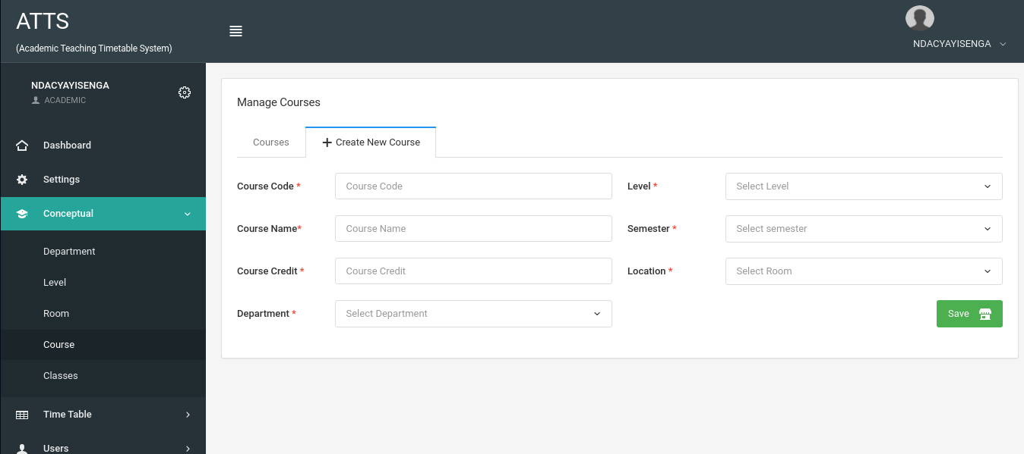

Figure 16 New course

This will allow academic service officer to add new course in academic year.

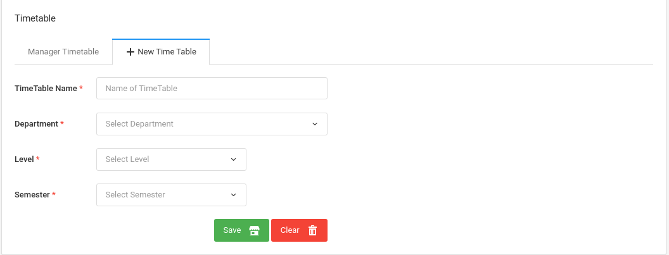

Figure 17 New timetable

The Academic service officer will have to create timetable by giving name of timetable chose department, level and semester also.

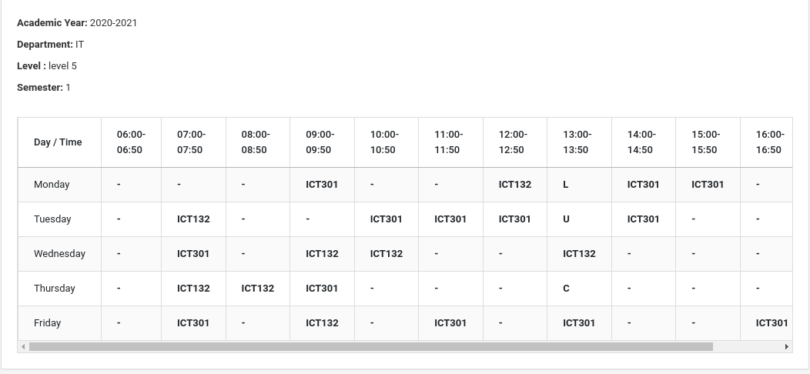

Figure 18 Timetable

The generated timetable will be shown once you need to view it.

**CHAPTER FIVE. CONCLUSION AND RECOMMENDATIONS**

**5.1 Conclusion**

In conclusion, The Academic Teaching Timetable system, is system that will generate timetable automatically without setting hours for every courses and the users who will view that timetable they will it according to academic year that has been created in time of implementation of it.

Some of users will view they few pages depends on role they have to the system. Such as academic role will view entire system and implement timetable.

From proper analysis and assessment of the designed system it can be safely concluded that the system is an efficient, usable and reliable Academic Teaching Timetable system. It is working properly and adequately meets the minimum expectations that were for it initially. The new system is expected to give benefits to the college and any other institution.

**5.2** **Recommendation**

I would like to recommend other researchers to work on how this system work and adding some features such as to mark every hour that has been taught on lecture. And also i recommend other researchers to show the weakness of my system. There is a future scope of this facility that many more features such as implementation of exams timetable and match them with class daily. Those features can be added to this project thus making it more interactive more efficient and system which fulfill each college wishes.

# References

|  |  |
| --- | --- |
| [1] | Wikipedia, "TimeTable," 11 February 2019. [Online]. Available: https://en.wikipedia.org/wiki/Timetable_(disambiguation). [Accessed 14 October 2021]. |
| [2] | S.-Y. Aris , C. Maisie and . L. Azreen, "school timetable," QuickSchools, 1 February 2016. [Online]. Available: https://www.quickschools.com/quickschools/features/scheduling. [Accessed 2 10 2021]. |
| [3] | Kamaleshwaram, "Timetable Management," Edsys Pvt Ltd, 2 january 2020. [Online]. Available: https://www.edsys.in/time-table-management/. [Accessed 12 11 2021]. |
| [4] | R. Kothari, "Timetable management system," my class campus, 1 6 2016. [Online]. Available: https://myclasscampus.com/home/school-coaching-time-table-management-software. [Accessed 23 11 2021]. |
| [5] | Wikipedia, "Application Software," 2 january 2021. [Online]. Available: https://en.wikipedia.org/wiki/Application_software. [Accessed 10 November 2021]. |
| [6] | A. W. West and Steve Prettyman, Practical PHP 7, MySQL 8, and MariaDB Website Databases: A Simplified Approach to Developing, Colyton, Devon, United Kingdom: Library of Congress Control Number: 2018957652, 2016. |
| [7] | S. Prettyman, Learn PHP 7: Object Oriented Modular Programming using HTML5, CSS3, JavaScript, XML, Stone Mountain, Georgia USA: Library of Congress Control Number: 2015960461, 2016. |
| [8] | GIMP, "GIMP software," GIMP, 29 june 2007. [Online]. Available: https://www.gimp.org/. [Accessed 10 November 2021]. |
| [9] | mysql, "Mysql workbench," mysql, 9 january 2021. [Online]. Available: https://www.mysql.com/products/workbench/. [Accessed 12 November 2021]. |
| [10] | phpmyadmin, "Documentation," phpmyadmin, 2 january 2003. [Online]. Available: https://www.phpmyadmin.net/docs/. [Accessed 12 November 2021]. |
| [11] | amazon, "Database Migration Service Documentation," amazon, 3 December 2020. [Online]. Available: https://docs.aws.amazon.com/dms/. [Accessed 12 November 2021]. |
| [12] | B. Michael , S. Dionysios and S. Victor, Pro HTML 5 and CSS3 Design Patterns, Co-authored Flash 5 studio, 2016. |
| [13] | M. Fowler, Applying Uml And Patterns An Introduction To Object-Oriented Analysis And Design, UML Distilled and Refactoring, 2016. |
| [14] | T. Otwell, "Framework," Laravel LLC, 4 january 2011. [Online]. Available: https://laravel.com/. [Accessed 3 October 2021]. |

|  |  |
| --- | --- |
| [1] | S. C. Herring, Should You Be Capitalizing the Word 'Internet'?, San Francisco: ISSN 1059-102830, 19 October 2015. |
| [2] | K. Petersen, C. Wohlin and Baca, "Product-Focused Software Process Improvement," in *Business Information Processing*, Berlin, ISBN 978-3-642-02152-7, 2009, pp. 386-400. |